GOLD SPONSORSHIP
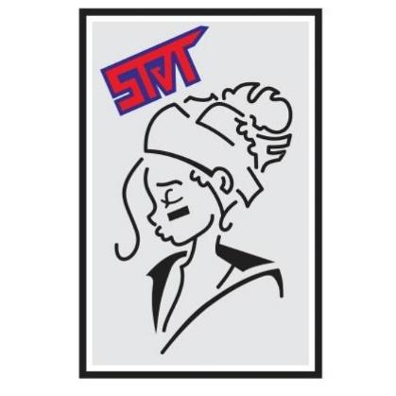
:REQUIREMENTS:
: MUST HAVE A YOUTUBE CHANNEL :
: MUST POST/PLAY WEEKLY :
: MUST HAVE PAYPAL VERIFIED ACCOUNT :
: MUST HAVE TEAM PATCH :
: MUST INCLUDE SPONSOR/SITE INFO ON YOUTUBE POST AND SOCIAL MEDIA POSTS :

:WHAT GOLD GETS YOU:
PAID ADMISSION TO AIRSOFT AREA’S AND BB’s | GAS OR EVENT PARTIAL REIMBURSEMENT | TWO ITEMS FOR GIVE AWAY ( UP TO 1,000$ )
UPGRADES AND MAINTENANCE | EQUIPMENT UPON REQUEST | MYSTERY BOX FOR CHRISTMAS

ALL GOLD BENEFITS MUST BE SUBMITTED PRIOR TO GOING TO EVENT OR ARENA AND ITEMS WILL BE SELECTED TOGETHER WITH AVAILABLE MONEY FOR THE MONTH. WORKING TOGETHER AS A TEAM TO BUILD UP THE SPONSORSHIP.

THIS IS A PROJECT SPONSORSHIP AND NOT A FINAL CONTRACT.
: ALL ITEMS SUBJECT TO CHANGE WITH NOTICE :

: SIGN AND DATE BELOW :

