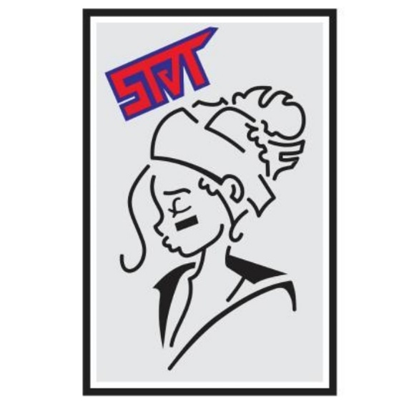 |  | Dear Future Sponsoree,  My name is Jacob and thank you for applying for this opportunity. I am the leader of Sky Fall Airsoft Team. I am sure we will continue to communicate as not only a Sponsor but as players. Today I would like to offer you three different types of sponsorship ( Black is a membership) I am willing to provide to you. There will be a sheet that provides more detail for each of these categories. Overall I want to reinforce that this is an open agreement/contract. There is no set time limit unless otherwise discussed and made amended to this contract. This can be retracted and advised at any time with no notice. I have one major rule before any talk over sponsorship is if you get caught cheating ( Not calling hits, violating field areas to gain advantages, stealing from other players, etc. ) I will revoke you of this contract as well as any money or items that have been given to the team. I will not pull any contract without notice or ample reason. By signing this agreement you understand this rule and circumstances. This will be a signed documentation to show that you agree to the terms of the sponsorship and availability. This means if you send me your airsoft items and I upgrade them, the items put in to your gun will be receipted to you and will be returned unless otherwise advised by only me ( Jacob Rodriguez ). I do not control supplies and other businesses for some of the offers. So please be patient with me. Also by signing this document you agree that you are over 18 years old. Please fill out the documentation fully. If you leave anything blank you will not be submitted into the next step.  These are the three sponsorships available at this time:  - GOLD - available  - Blue - available  - Red - available  - (BLACK) ask for details  Thank you for your time, Respectfully  Jacob Rodriguez – Leader of Sky Fall Airsoft Team

SKY FALL AIRSOFT TEAM
LEADER

CONTACT
PHONE:
Group chat for Whatsapp.

WEBSITE:
DZAPSFAT.com

EMAIL:
skyfallairsoftteam@gmail.com

